**Name: Muhammad Shoaib Khan**

**Seat Number: B12101087**

**Class: BSCS 2nd Year (Section A)**

**Object-Oriented Programming**

**(Assignment 1)**

**Object: Write a program in C# to assign values to two integers values variables and then apply the basic arithmetic operations. You can use two as well as three variables operations. Output the program using both operations.**

**Operation 1:**

using System;

using System.Collections.Generic;

using System.Linq;

using System.Text;

using System.Threading.Tasks;

namespace ConsoleApplication1

{

class Program

{

static void Main(string[] args)

{

int a=2, b=2;

Console.WriteLine("The sum of the numbers is: {0}", a + b);

Console.WriteLine("The Product of the numbers is: {0}", a * b);

Console.WriteLine("The Division of the numbers is: {0}", a / b);

Console.WriteLine("The Subtraction of the numbers is: {0}",a- b);

Console.ReadKey();

}

}

}

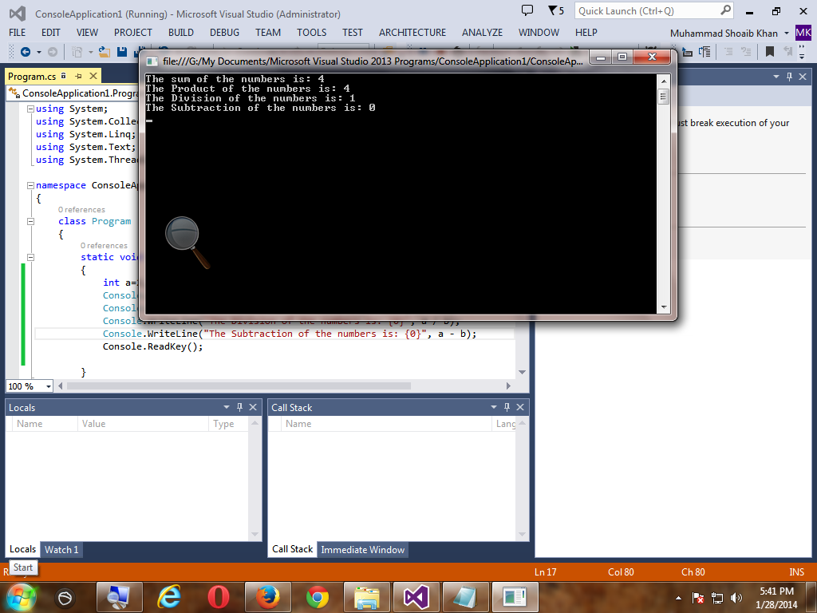

**Operation 2:**

using System;

using System.Collections.Generic;

using System.Linq;

using System;

using System.Collections.Generic;

using System.Linq;

using System.Text;

using System.Threading.Tasks;

namespace Assignment2

{

class Program

{

static void Main(string[] args)

{

int a = 2, b = 2, c;

c=a+b;

Console.WriteLine("The sum of the numbers is: {0}",c);

c=a*b;

Console.WriteLine("The Product of the numbers is: {0}",c);

c=a/b;

Console.WriteLine("The Division of the numbers is: {0}", c);

c=a-b;

Console.WriteLine("The Subtraction of the numbers is: {0}",c);

Console.ReadKey();

}

}

}

